**]\\\\\\\\\\\\\\\\\\\\\\\\\\\\\\\\\\\\\\\\\\\\\\\\\\\\\\\\\\\\\\\\\\\\\\\\\\\\\\\\\\\\\W1-S2** GROUP REFLECTION

*Design Principles*

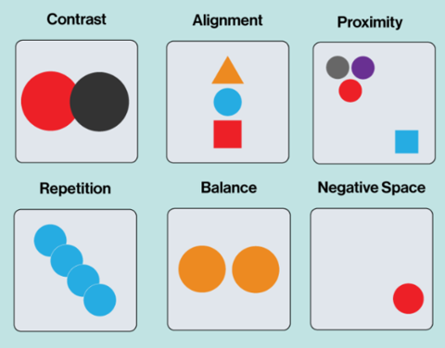

For this session: Make groups of 3 students.

|  |  |
| --- | --- |
|  | Group work *(60 min)* |

You need to need to analyze **3 graphical designs** (choose among the ones bellow)

* Complete the evaluation table for each analysis
* Propose improvements if needed *(just ideas. You don’t have to draw anything)*

|  |  |
| --- | --- |
|  | Group presentations *(15 min)* |

It’s time to share you group work to the whole class

* 1 speaker per group
* Speakers are randomly selected to present each group work activity

*WORK 1*

Which design you choose? (letter): **C**

|  |  |  |
| --- | --- | --- |
| *CATEGORY* | *CRITERIA* | *YOUR ANLAYSIS* |
| CONTRAST | * Does the design use enough contrast to differentiate elements? * Do the elements with high contrast stand out as intended? | No, it doesn't.  Because the pink color and white doesn’t contrast each other well  No, The blue text and the cup cake look out of place. |
| ALIGNMENT | * Are text, images, and other elements aligned properly to create order and cohesiveness? * Are there any elements that feel "out of place"? | No, the cupcake photo aligned but the text is not well aligned and it look weird.  Yes, the cupcakte box in the top left corner of the screen. |
| PROXIMITY | * Are headlines, body text, and images that belong together placed near each other? * Are elements spaced too far apart or too close together? | Yes, everything that belong together are placed near eacher other.  Yes, the space between top bar and the title are too big. |
| REPETITION | * Are colors, fonts, or shapes used consistently across the design? * Does the repetition feel intentional and effective? | No, the font color are changing from pink to blue and then black.  Yes, the menu area repetition feel intentional. |
| WHITE SPACE | * Does the design have enough white space to avoid overcrowding, or does it feel empty? * Is the white space used to guide the viewer's eye effectively? | It feel empty because of all the space leaving between the cupcake pictures and space between line.  No the white space make the design look bad. |
| BALANCE | * Is the design the same on both sides or does one side have more weight than the other? * Does the design feel even and comfortable to look at, or does it feel lopsided and uneven? | The two side are well balanced.  The design feel weird and uncomfortable to look at. |
| **IMPROVEMENTS** | * Write your improvement proposition (*If any)* | **The font below the cupcake should be bigger and bold for the user to see more easily.** |

*WORK 2*

Which design you choose? (letter): A

|  |  |  |
| --- | --- | --- |
| *CATEGORY* | *CRITERIA* | *YOUR ANLAYSIS* |
| CONTRAST | * Does the design use enough contrast to differentiate elements? * Do the elements with high contrast stand out as intended? | Yes the white background contrast with black font color well.  No, everything look the same. |
| ALIGNMENT | * Are text, images, and other elements aligned properly to create order and cohesiveness? * Are there any elements that feel "out of place"? | No, everything are in one line and it’s hard to differentiate between food and price and description  No, everything are okay. |
| PROXIMITY | * Are headlines, body text, and images that belong together placed near each other? * Are elements spaced too far apart or too close together? | No, everything mixed up together.  All elements are too close together. |
| REPETITION | * Are colors, fonts, or shapes used consistently across the design? * Does the repetition feel intentional and effective? | Yes, the font and color are consistent  No, it look messy and hard to read. |
| WHITE SPACE | * Does the design have enough white space to avoid overcrowding, or does it feel empty? * Is the white space used to guide the viewer's eye effectively? | It feel crowded.  No, I have read it for a while to get the meaning of this. |
| BALANCE | * Is the design the same on both sides or does one side have more weight than the other? * Does the design feel even and comfortable to look at, or does it feel lopsided and uneven? | The left side has more weight.  The design is hard to read, crowded, confusing. |
| **IMPROVEMENTS** | * Write your improvement proposition (*If any)* | **The font size and font color of the description should be smaller and less contrast than the food name and price.** |

*WORK 3*

Which design you choose? (letter): B

|  |  |  |
| --- | --- | --- |
| *CATEGORY* | *CRITERIA* | *YOUR ANLAYSIS* |
| CONTRAST | * Does the design use enough contrast to differentiate elements? * Do the elements with high contrast stand out as intended? | Yes, color red and white background does contrast each other well.  Yes, I can see the text clearly. |
| ALIGNMENT | * Are text, images, and other elements aligned properly to create order and cohesiveness? * Are there any elements that feel "out of place"? | The text are not align well.  The text’s indentation is bad and the whole text is a bit off center.  No, everything look okay together. |
| PROXIMITY | * Are headlines, body text, and images that belong together placed near each other? * Are elements spaced too far apart or too close together? | The title should be bigger and place a bit further from body.  The title and body text look too close together creating confusion for the reader. |
| REPETITION | * Are colors, fonts, or shapes used consistently across the design? * Does the repetition feel intentional and effective? | Yes. The color and font are consistent.  Yes the repetition in this post work well. |
| WHITE SPACE | * Does the design have enough white space to avoid overcrowding, or does it feel empty? * Is the white space used to guide the viewer's eye effectively? | The body text look okay with this spacing but the ‘Tow-away’ need a bit more spacing.  No, the title, the body and, the warning are too close it look like they belong together. |
| BALANCE | * Is the design the same on both sides or does one side have more weight than the other? * Does the design feel even and comfortable to look at, or does it feel lopsided and uneven? | The left side has more weight because the whole text are off to the left.  It look uncomfortable to look at. |
| **IMPROVEMENTS** | * Write your improvement proposition (*If any)* | **The whole text should be place in the center.**  **And the title ‘Tow-away’ should be bigger to make it more visible.**  **The warning should have something to make it stand out from the rest of the text.** |

*DESIGN A*

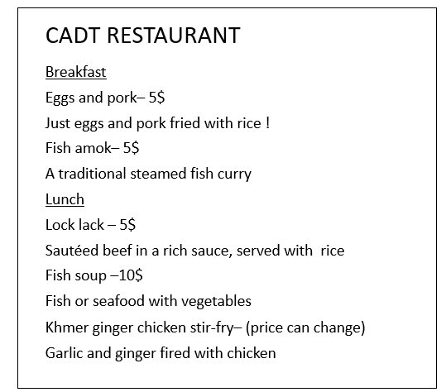

*DESIGN B*

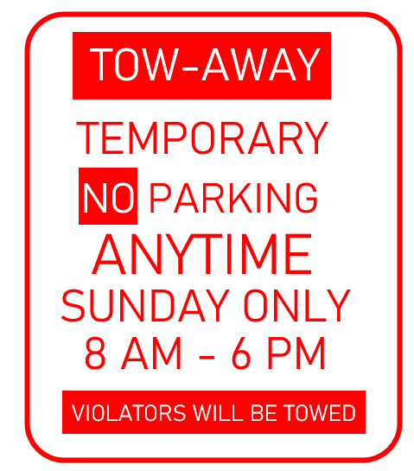

*DESIGN C*

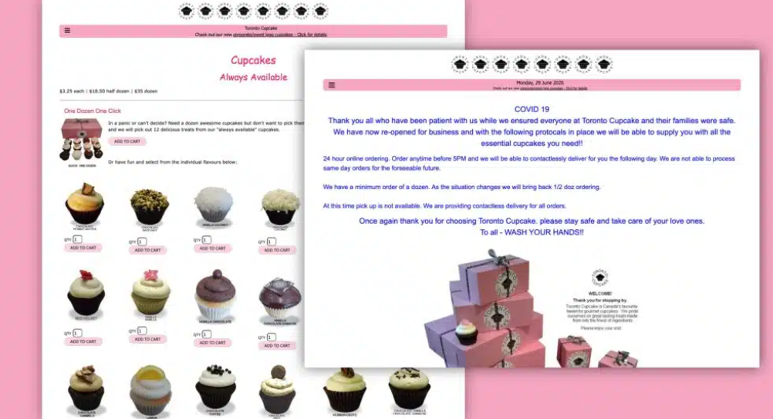

*DESIGN D*

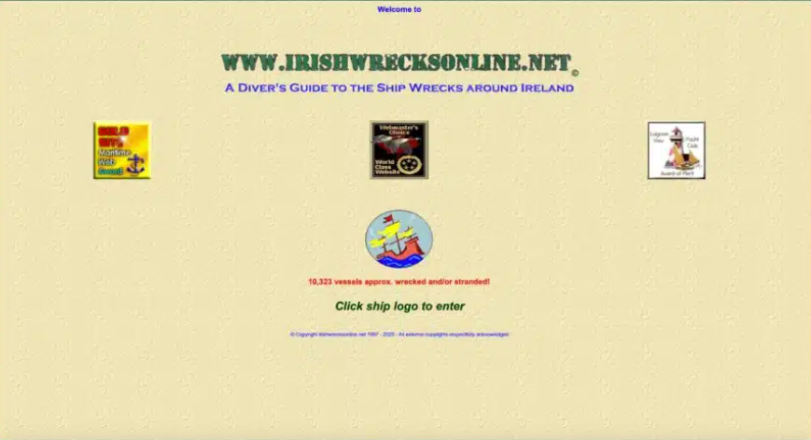

*DESIGN E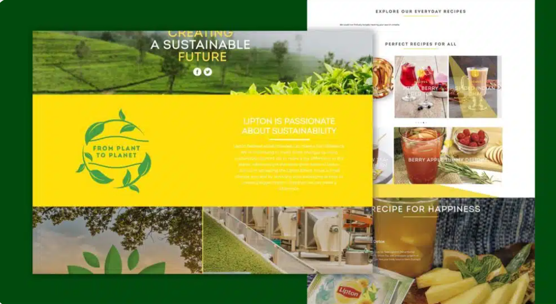*

*DESIGN F*

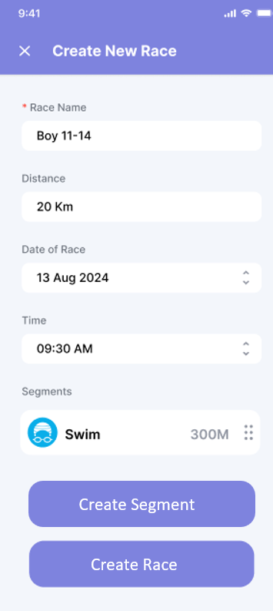

*DESIGN G*

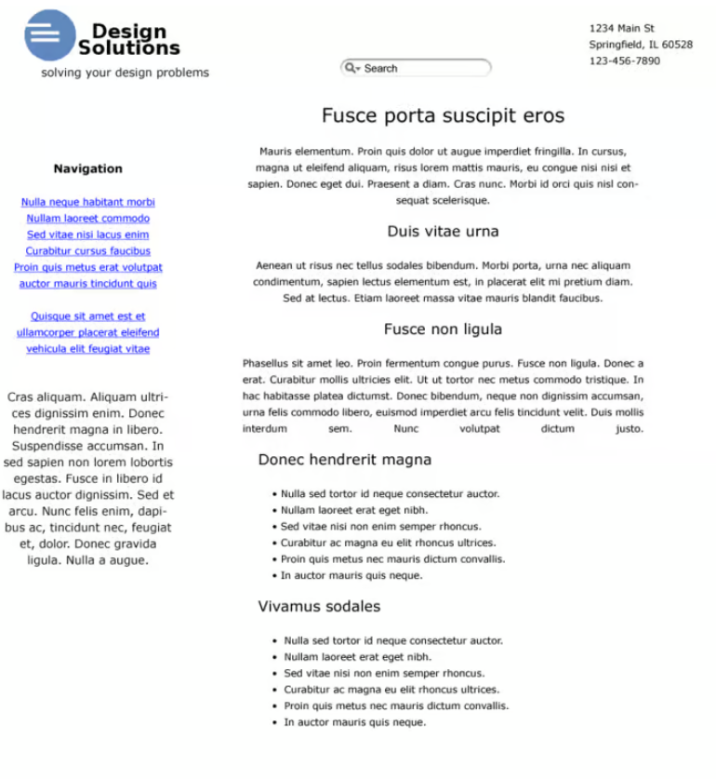

*DESIGN H*

